**How to access FTP Server using Notepad++**



Notepad++ is fairly a small application and occupies 5 MB on your drive. You needed to have a client application to transfer files to FTP or Web Servers. After you connect your server with the client application like [FileZilla](http://www.thewindowsclub.com/setup-filezilla-server-edition-screenshot-tutorial" \o "Filezilla download" \t "_blank), a [free FTP application](http://www.thewindowsclub.com/top-3-ftp-applications-for-your-windows-pc), the file is then edited back using a notepad or an IDE.

Notepad++ combines the features of different application using its **NppFTP plug-in**. This enables you to access all the files and folders on your Web server. Moreover you can create new directories as well.

**Notepad++ FTP connection setup**

First of all you need to download the latest version of Notepad++; it hardly takes any time to install. Also note that the latest version of Notepad++ has FTP plugins installed with it. If you are running an older version of Notepad++ then you need to install the plugins separately through plugin manager. You just need to launch the plugin, which is done by clicking plugins **NppFTP** show NppFTP Window.

[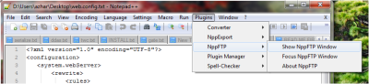](http://thewindowsclub.thewindowsclubco.netdna-cdn.com/wp-content/uploads/2012/02/Notepadd++-FTP.png)

**Configuring FTP connection on Notepad++**

[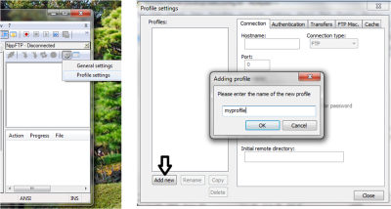](http://thewindowsclub.thewindowsclubco.netdna-cdn.com/wp-content/uploads/2012/02/Notepadd++-FTP1.png)

After launching the NppFTP windows, all you need to do is to configure the FTP connection, which is done by clicking the General setting option under the Settings tab.

The next step is to add new profile. Click the button ‘add new’ on the bottom left of the window and enter the name of the profile you would like to have.  Enter all the FTP or Web Server details, which include:

* Hostname
* Username
* Password
* Port

The port for **FTP** is always set as 21 – and choose the connection type as ‘FTP’.

[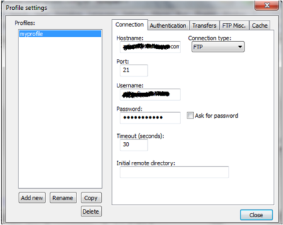](http://thewindowsclub.thewindowsclubco.netdna-cdn.com/wp-content/uploads/2012/02/Notepadd++-FTP2.png)

Once you are done with the entries, start accessing your FTP Server just by establishing connectivity. Which is done by hitting the connect button on the FTP Window.

[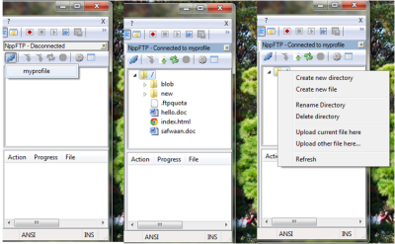](http://thewindowsclub.thewindowsclubco.netdna-cdn.com/wp-content/uploads/2012/02/Notepadd++-FTP3.png)

There are bunch of option you can do using this, such as:

1. Edit the file on the Notepad++ directly.
2. Upload a new file.
3. Delete a file.
4. Create a new directory.
5. Delete a directory.